[YOUR PROJECT NAME]
Software Architecture

Submitted to:

Asst. Prof. Ma. Rowena C. Solamo
Faculty Member
Department of Computer Science
College of Engineering
University of the Philippines, Diliman

Submitted by:
[List of Members in Alphabetical Order]

In partial fulfillment of Academic Requirements
for the course
CS 191 Software Engineering I
of the
1st Semester, AY <YYYY-YYYY>
Revision Control

History Revision:
Revision Date | Person Responsible | Version  Number | Modification
MM/DD/YY | Juan de la Cruz | 1.0 | Initial Document; Version number should match the one found in the footer.  I expect only one member name here. The person responsible in creating the document. This ensures accountability.

Purpose:

[Place purpose of the document here.]

Audience:

[Place the description of the people who will be reading this document.]
System Name: [Name of the System eg. Athlete Record Maintenance System]

Description: [Brief Description of the System in 3-7 sentences.]

Software Architecture Diagram:

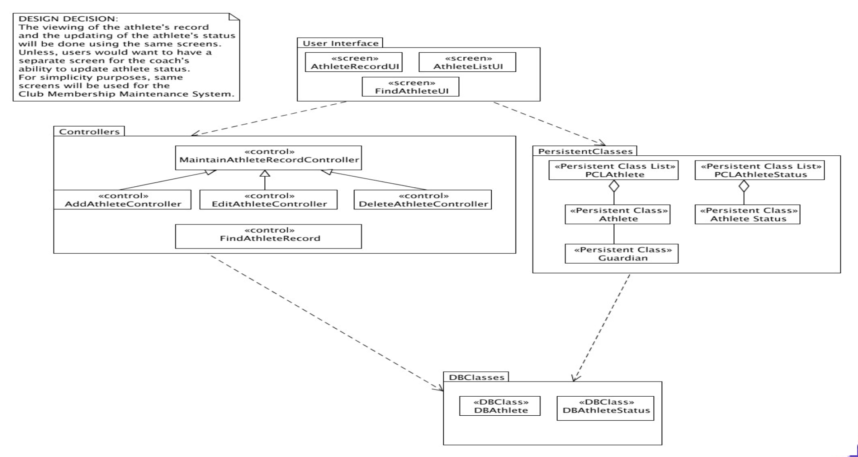

User Interface Design Classes:

Screen Name | Description
AthleteRecordUI
AthleteListUI
FindAtheleteUI

Business Logic Classes:

Control | Description
AddAtheleteController
DeleteAtheleteController
EditAthleteController
FindAthleteController

Data Design Classes:

Class Name | Description
DBAthlete
PCLAthleteList
Athlete
Guardian
PCLAthleleteStatus
AthleteStatus

